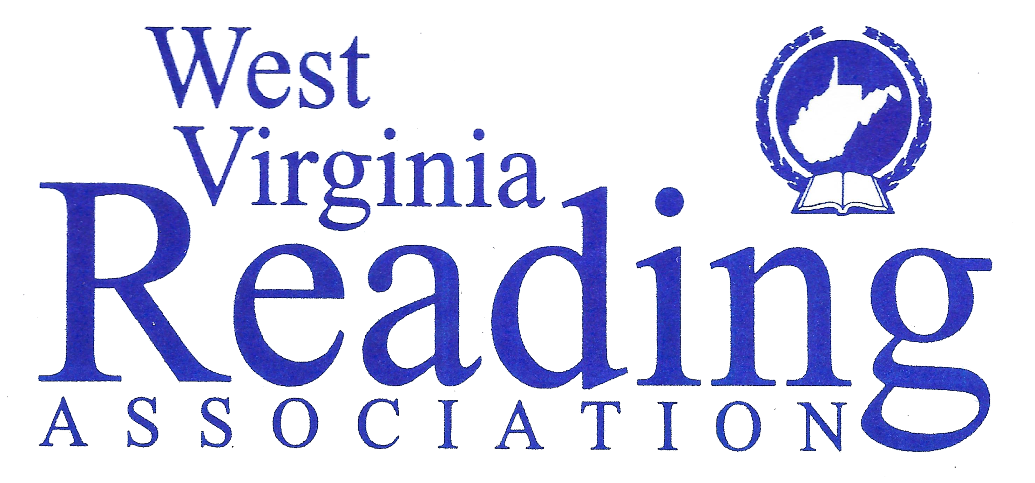

Media Release Form for state district and local council events

The West Virginia Reading Association (WVRA) at the state, district, and local council levels will be taking pictures and/or videos during WVRA sponsored activities. The purpose for taking these pictures and videos is to publicize the work of WVRA. These pictures may be posted on the West Virginia Reading Association Home page at www.wvreading.org, or WVRA Facebook, _______________, WVRA District Homepages, Local Council Homepages, or through any other social media outlet that WVRA may use to promote the Association. By signing the form below, I agree to allow the West Virginia Reading Association to post my picture in the media outlets stated above.

WVRA Media Release Permission Form

I hereby grant the West Virginia Reading Association permission to use my photo or video taken
On _____________________________(Date)
During_____________________________________(The event)
Printed Name_________________________________________________

Signed _____________________________________________

An additional Parent or Guardian Signature is required if the person is a child under age 18 in order for the photo or video to be released.

Signed______________________________________________

